One Path  
Standard Operating Procedures

CUSTOM LEARNING DESIGNS, INC.  
375 Concord Avenue  
Belmont, MA 02478 (617) 489-1702  
  
January 7, 2013

**SHI-13**

One Path  
Standard Operating Procedures



Designed and Developed with CLD cldinc.com  
Copyright 2013. Shire.  
All Rights Reserved.  
SHI-13 (01/13)

Table of Contents

[Title Placeholder (Heading 1) **Error! Bookmark not defined.**](#_Toc344986333)

**Note: If you have difficulty working in this template due to a slow redraw it helps to turn off background graphics while you type. To do this in Windows 7 click on the Office Button in the top left corner of your screen, choose advanced, and uncheck "Show drawings and text boxes on screen." Be aware that quick tips will not be visible so take care not to delete the paragraph mark associated with them.**

# Creating a Physician Entry in SalesForce

## SOP 2: 1/9/13

Number Effective Date Department

## Approval

**Jane Doe**, *Title*–Department Name

## Purpose and Scope

This SOP defines the process of adding a new physician entry into SalesForce. It describes:

* Finding a physician in SalesForce, ,
* Creating a physician for an existing address (Site of Care –SOC) or
  + Creating a new SOC for a new physician
* Linking the physician’s SOC to physician’s records.

## Roles and Responsibilities

**Case Management Specialist** – the role within the OnePath Case Management Team responsible for receiving inbound phone calls and processing inbound faxes. The CMS typically takes care of entering physicians into SalesForce.

**Case Manager** – the role within the OnePath Case Management Team responsible for ensuring that reimbursement and overall case needs are met for all patients, sites, field support, etc. This person can perform the roles of the CMS but typically does not.

### Finding a Physician in SalesForce

If a physician’s office faxes a New Patient Start Form to Shire, the CMS first checks the SalesForce database to ensure that the physician is listed. A new patient case cannot be created unless the physician or SOC listed on the Start Form has already been entered in SalesForce.

#### The first step to finding a physician is to go into SaleForce:

#### On the home page, type the first three letters of the physician’s last name into the search bar in the upper left-hand corner of the SalesForce screen.

#### NewPT_PartA_#3

#### If the name is illegible or not showing, try alternate spellings

#### Try by name or physician’s practice

#### Try by last and first names

#### Confirm that the physician is not already in the system before adding the physician in as a new entry.

### **C**reating a New Physician for an Exiting SOC

#### If the physician is not in the database, the CMS goes through the process of either adding the physician to an existing Site of Care (SOC) or creating a new SOC if one does not exist in the SalesForce database. **To find an existing SOC do the following:**

1. **Start** in the “**Home**” page of SalesForce.
2. **View** the tabs in the left-hand side of the screen.

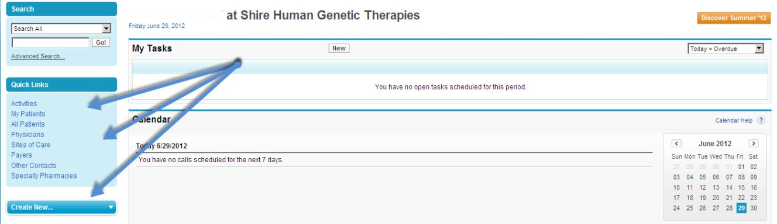

1. **Click** “**Create New**”.
2. A drop-down menu will appear with the options: “**Task**”, “**Contact**”, “**Account**”, “**Product Shipment**” and “**Report**”.
3. **Disregard** the options “**Task**” and “**Report**”.
4. **Select** “**Contact**”.

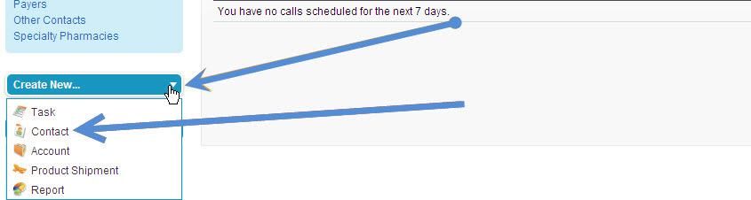

1. In the “Record Type of New Record” bar, **select** “**Physician**”.
2. **Click** “**Continue**”.

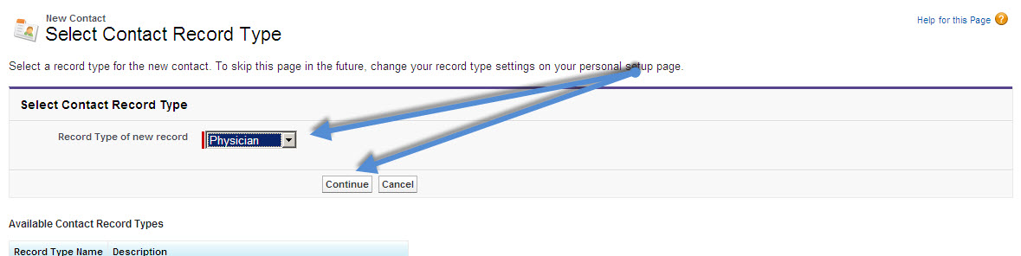

1. **Fill-in** all the information you have available.

All the spaces that have **red** bar next to them MUST be filled-in.

1. **Click** “**Create Contact**”.

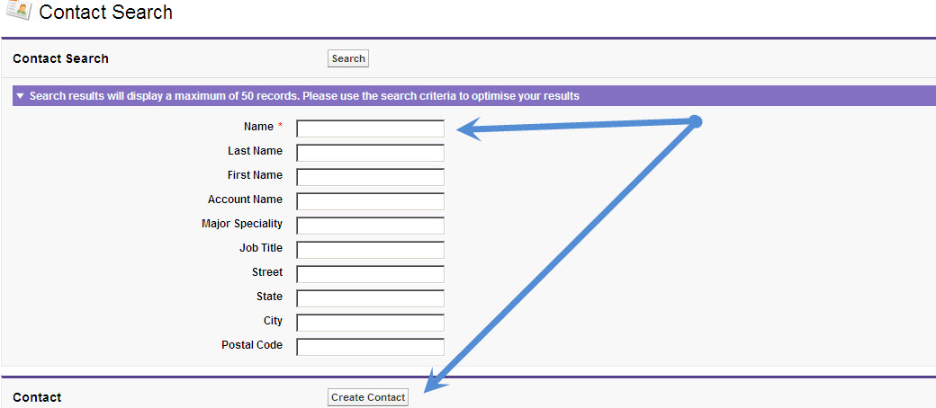

**An easier way to do this is to go into the Account record, click on the contacts tab, and then click new contact. It will prefill all the account details (Address phone, etc.) and they can be edited.**

Quick Tip

### **C**reating a New SOC for a New Physician

#### If there is no existing SOC for a new physician, the CMS creates a new SOC.

#### **To create a new SOC do the following:**

#### At the top of SaleForce on the upper left hand side **select** “**Account**”.

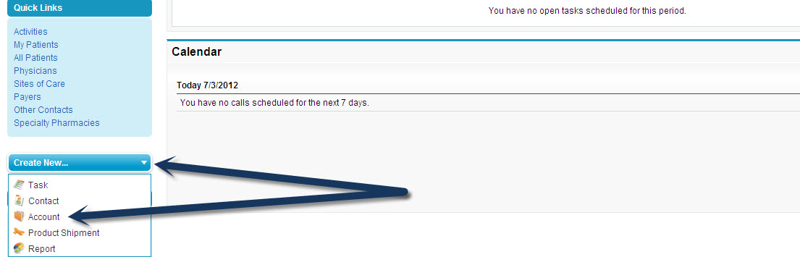

1. In the “**Record Type of New Record**” section, **click** the downward **arrow**.
2. **View** the options from the drop-down menu.
3. **Select** “**US Physician Account/Site of Care**”.

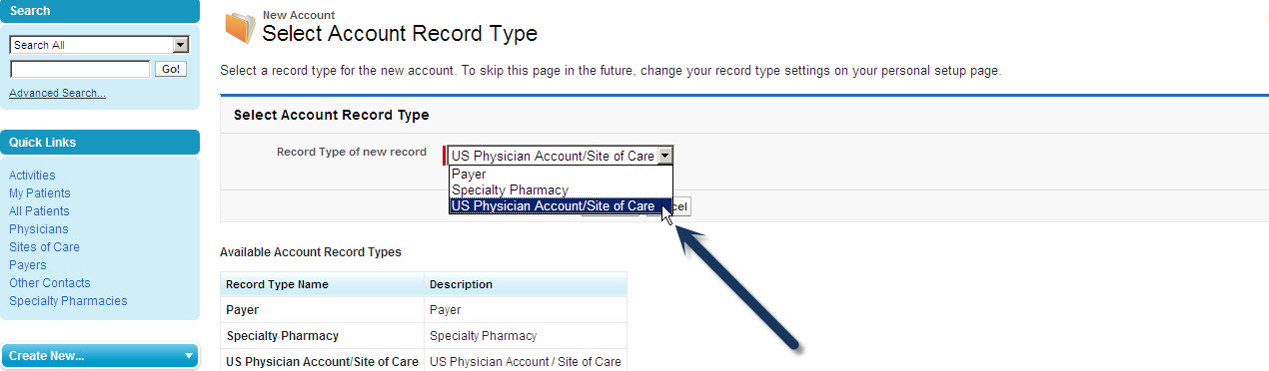

1. **Click** “**Continue**”.
2. **Fill-in** all the information you have available. All the spaces that have **red** bar next to them MUST be filled in
3. Selec the product by going under “**Products**” **select** “**Firazyr**”
4. **Click** “**Save**”.

### NewSoc_#8

### **Linking a SOC to a Physician’s Records**

#### Once a physician’s contact has been created in SalesForce, the CMS must link the SOC to the physician’s records. **To link a SOC to physician’s records do the following:**

1. **Start** at the “**Home**” page of SalesForce.
2. **Type** the first three letters of the physician’s last name into the search bar in the upper left-hand corner of the page.
3. **Click** “**Go!**”

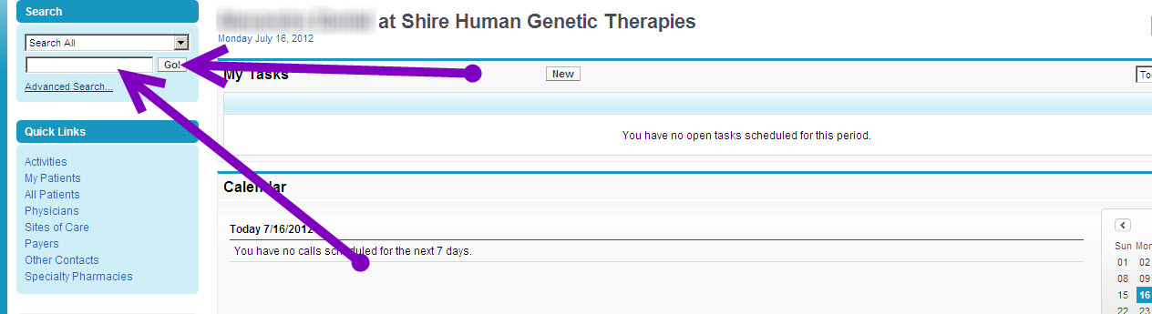

1. **Scroll** through the results.
2. **Click** the **Physician’s name**.
3. The physician’s “**Contact Detail**” (**blue**) page will now appear.

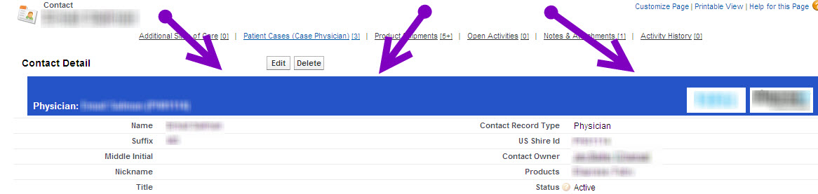

1. **Click** “**Edit**” at the top of the page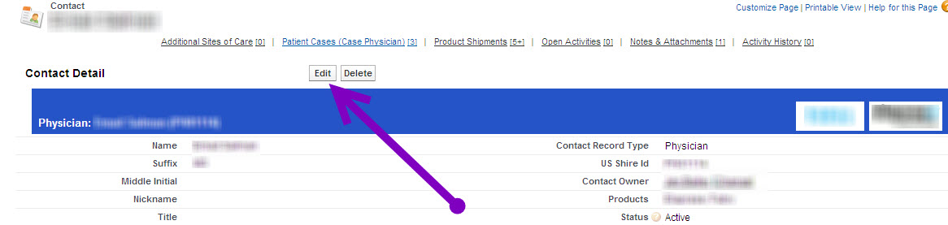
2. **Scroll** down to the “**Site of Care**” section.
3. **Click** the **small microscope** graphic to the right of the bar to search.

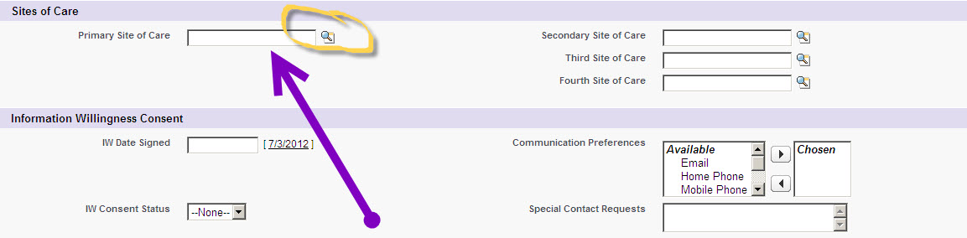

1. **Select** the SOC.
2. **Scroll** down to the top of the page.
3. **Click** “**Save**”.

